Titre | Phylogeography of a large adaptive radiation, the case study of Malagasy olive trees
Encadrant 1  (tel + mail) | Jordi Salmona  +33 0561556758 ; jordi.salmona@gmail.com
Encadrant 2  (tel + mail) | Guillaume Besnard  guillaume.besnard@univ-tlse3.fr
Equipe(s) | EDB, UMR-5174, équipe DEEP, UPS, Bâtiment 4R1
Résumé | Our knowledge of biodiversity is highly biased toward common species with large geographical ranges. This challenges the urgent need of describing, understanding and conserving biodiversity. This also limits our capacity to understand the evolutionary processes that generated biodiversity, especially in the “hottest” biodiversity hotspots^{1,2}. In particular, Madagascar’s long-term relative isolation as well as its complex topography, orography, hydrography and climates resulted in high levels of endemism^{3,8} and contributed to a large number of radiative diversifications across all kingdoms³. Major models of diversification and species formation have been proposed in Madagascar^{8–13}: (i) The adaptive “ecogeographic constraint”⁹ model proposes that species originally widespread throughout eastern and western Madagascar slopes adapted to dry versus humid conditions and then diverged into separate species. (ii) In contrast, the “mountain refugia”¹⁰ mechanisms suppose that mountain massifs acted as refugia for humid forests species during periods of drier climate. (iii) Similarly, the “western rainforest refugia” hypothesis assumes that rainforests species spread from the East into western Madagascar during humid periods where they further diverged in isolated areas during dry periods. (iv) The “Riverine barrier” mechanism¹¹ suggests that rivers acted as the primary barrier to gene flow, leading to speciation especially in lowlands, where they are at their widest. (v) Finally the “watershed elevation” model⁴ proposes that microendemism is concentrated in regions of low watershed elevation isolated during drier periods, while high watershed elevation regions served as zones of retreat-dispersion and are expected to show lower levels of endemism. These models were tested across various families and/or genera^{9,12–16}. However, sampling incompleteness, low phylogenetic resolution and/or the complexity of evolutionary forces simultaneously at stake, yet limited the reach of our understanding of the evolutionary mechanisms underlying Madagascar tremendous biodiversity^{12,14,15}.  This project aims, at uncovering the major drivers of diversification and species formation in Madagascar from robust phylogeny reconstructions. The project will focus on the Malagasy olive tree (Noronhia; Fig. 1), at the island level and across Neogene and Quaternary (last 20 million years). From already generated RAD-seq data across > 100 lineages (Fig. 2) the candidate will produce and calibrate robust phylogenomic inferences^{17–20}. S/he will then infer biogeographic histories and test the major island-wide diversification models²¹ proposed for Madagascar^{4,7,11,22}. The work will be conducted in collaboration with Cynthia Hong-Wa (Delaware Univ.). It also integrates an international BiodivERsA funded project (INFRAGECO: Inferences, fragmentation, population genetics and conservation), and may involve collaborations with its partners (i.e., Lounès Chikhi, EDB-Toulouse & IGC-Lisbon; Christophe Thébaud, EDB Toulouse) and will benefit fromthe expertise of collaborators at EDB and in Madagascar (WRI, KMCC, MBG).  The student is expected to work in relative autonomy, to have preliminary knowledge in population genetics, in R and Bash scripting and great interest in evolution.  References : 1 Myers, N. et al. Nature 403, 853–858 (2000); 2 Ganzhorn, J. U. et al. Oryx 35, 346–348 (2001); 3 Vences, M. et al. Trends Ecol. Evol. 24, 456–465 (2009); 4 Wilmé, L. et al. Science 312, 1063–1065 (2006); 5 Dewar, R. E. et al. Proc. Natl. Acad. Sci. 104, 13723–13727 (2007); 6 Colwell, R. K. et al. Trends Ecol. Evol. 15, 70–76 (2000); 7 Pearson, R. G. et al. Evolution 63, 959–967 (2009); 8 Goodman, S. M. et al. Oryx 39, 73–77 (2005); 9 Yoder, A. D. et al. in Primate Biogeography, Springer, pp. 255–268 (2006); 10 Boumans, L. et al. Mol. Phylogenet. Evol. 45, 822–839 (2007); 11 Martin, R. D. Z. Für Tierpsychol. 9, 43–89 (1972); 12 Brown, J. L. et al. Nat. Commun. 5, 5046 (2014); 13 Reddy, S. et al. Proc R Soc B 20112380 (2012); 14 Weyeneth, N. et al. J. Biogeogr. 38, 44–54 (2011); 15 Hong-Wa, C. et al. Bot. J. Linn. Soc. 174, 141–161 (2014); 16 Townsend, T. M. et al. Syst. Biol. 58, 641–656 (2009); 17 da Costa, J. M. et al. PLoS ONE 9, e106713 (2014); 18 Stamatakis, A. Bioinformatics 30, 1312–1313 (2014); 19 Bryant, D. et al. Mol. Biol. Evol. 29, 1917–1932 (2012); 20 Chifman, J. et al. Bioinformatics 30, 3317–3324 (2014); 21 Matzke, N. J. Probabilistic Historical Biogeography, University of California, Berkeley (2013); 22 Schatz, G. E. Divers. Endem. Madag. 1, 1–8 (2000).
Figures | 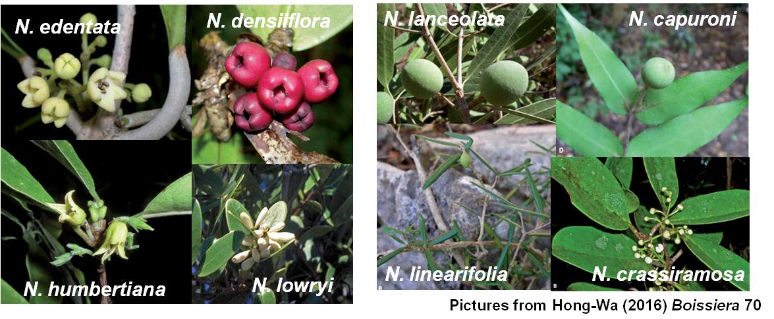  Figure 2. Sampling locations of Noronhia accessions analyzed with RAD-seq data  Figure 1. Examples of flowers and seeds of Noronhia

